Multiple-choice section – choose the correct answer

Question 1 [12.1]

Which equation is non-linear?

A  B 1 = C 2y = 7x – 4 D 

Question 2 [12.4] [10A]

When simplified, the value of  is:

A 72 B 26 C 18 D 6

Question 3 [12.3]

8x4 × 2x6 simplifies to:

A 16x24 B 40x8 C 16x10 D 10x10

Question 4 [12.3]

When simplified, (4x6)3 is equivalent to:

A 12x9 B 8x9 C 64x9 D 64x18

Question 5 [12.5] [10A]

The value of (32) is:

A 5 B 10 C 16 D 64

Question 6 [12.5] [10A]

The value of  is:

A 0.5 B -5 C 2 D -2

Question 7 [12.1]

The horizontal asymptote of the graph of  is:

A x = 3 B y = 5 C y = 0 D y = 3

Question 8 [12.1]

The hyperbola with equation y =  – 7 has horizontal and vertical asymptotes at:

A x = -7, y = 4

B x = 4, y = -7

C x = -7, y = -4

D x = -4, y = 7

Question 9 [12.2]

The graph of  is:

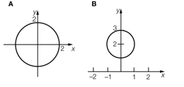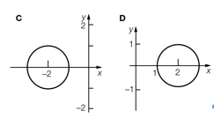

Multiple-choice results: ___ / 9

Short answer section

Question 10 2 marks [12.3]

Choose from the following words to complete the sentences below.

base coefficient index irrational number power surd

In the term 5x6, the ‘6’ is known as the _______________ or _________ of x.

Question 11 1 mark [12.5] [10A]

Complete the following sentence.

(243) = 5 because ______________________________________________________

Question 12 2 marks [12.4] [10A]

Simplify .

Question 13 4 marks [12.4] [10A]

Evaluate using index laws:

(a) 5 ×  (b) 

Question 14 2 marks [12.3]

Write  in simplified form expressing your answer with positive indices.

Question 15 6 marks [12.5] [10A]

Solve the following equations.

(a) (x) = 5 (b) (1000 ) = 4 (c) 2(x) + 4 = 12

Question 16 4 marks [12.6] [10A]

Simplify the following using logarithmic laws.

2(2) + (125) – (5)

Question 17 3 marks [12.1]

(a) Complete the table of values below for:

(i) y = 2x + 1

|  |  |  |  |  |  |  |
| --- | --- | --- | --- | --- | --- | --- |
| x | 0 | 1 | 2 | 3 | 4 | 5 |
| y |  |  |  |  |  |  |

(ii) y = 3x − 64

|  |  |  |  |  |  |  |
| --- | --- | --- | --- | --- | --- | --- |
| x | 0 | 1 | 2 | 3 | 4 | 5 |
| y |  |  |  |  |  |  |

(b) State the coordinates of the point of intersection of the two graphs.

Question 18 8 marks [12.2]

(a) Explain the transformations required to obtain (x – 2)2 + (y + 4)2 = 81 from (x + 1)2 + (y – 5)2 = 81.

(b) Explain the transformations required to obtain y = 2(*x* + 3) + 5 from y = 2*x*.

(c) Explain the transformations required to obtain y = + 4 from y = .

Short answer total:_________/32

Extended answer section

Question 19 8 marks [12.2]

(a) If the circle with equation (x – 6)2 + (y + 5)2 = 16 is reflected in the x-axis:

(i) State the coordinates of the centre of the reflected circle.

(ii) State the radius of the circle.

(iii) Find the equation of the reflected circle.

(iv) What translation would produce the same equation?

(b) Find the equation of the circle found in part (a)(ii) if it is now reflected in the y-axis.

(c) If the circle with equation (x – 6)2 + (y + 5)2 = 16 is reflected in the y-axis and then reflected in the  
x-axis, find the equation of the reflected circle.

(d) Are the answers to part (b) and part (c) different?

Question 20 8 marks [12.1]

When heated, the temperature T °C of a bar of metal increases according to ,  
where t is the time in seconds.

(a) If the temperature is 24 °C after 10 seconds, what is the value of k?

(b) What was the initial temperature of the metal bar?

(c) Show that after 20 seconds the temperature of the metal will be 15 °C hotter than its initial temperature.

(d) Which three points can now be used to sketch the graph of  for 0 ≥ t ≥ 10?

Question 21 8 marks [12.2]

The graph of the hyperbola in the form of  is shown below.

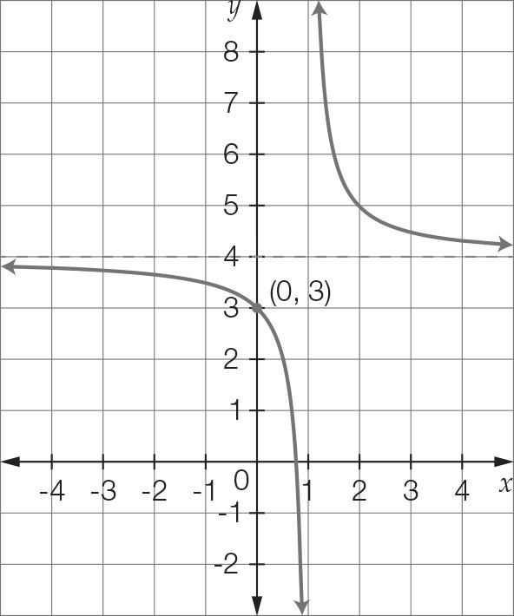

(a) State the value of the horizontal asymptote.

(b) State the value of the vertical asymptote.

(c) Given that the y-intercept is (0, 3), find the equation of the hyperbola.

(d) Calculate the value of the x-intercept.

Question 22 10 marks [12.6] [10A]

If (2) ≈ 0.3010, (3) ≈ 0.4771 and (5) ≈ 0.6990, find approximate values for:

(a) (32)

(b) (15)

(c) 

(d) (20)

(e) (22.5)

Extended answer total:_______ /34

TOTAL test results: _______ / 75